DATA MINING PROJECT

BATCH-18

horse-colic.tab

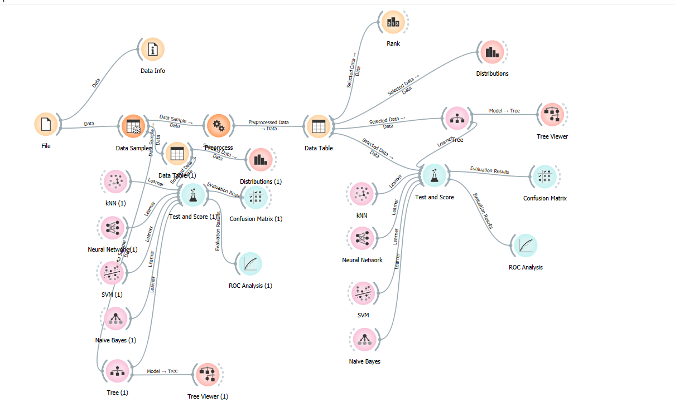Dataset info:

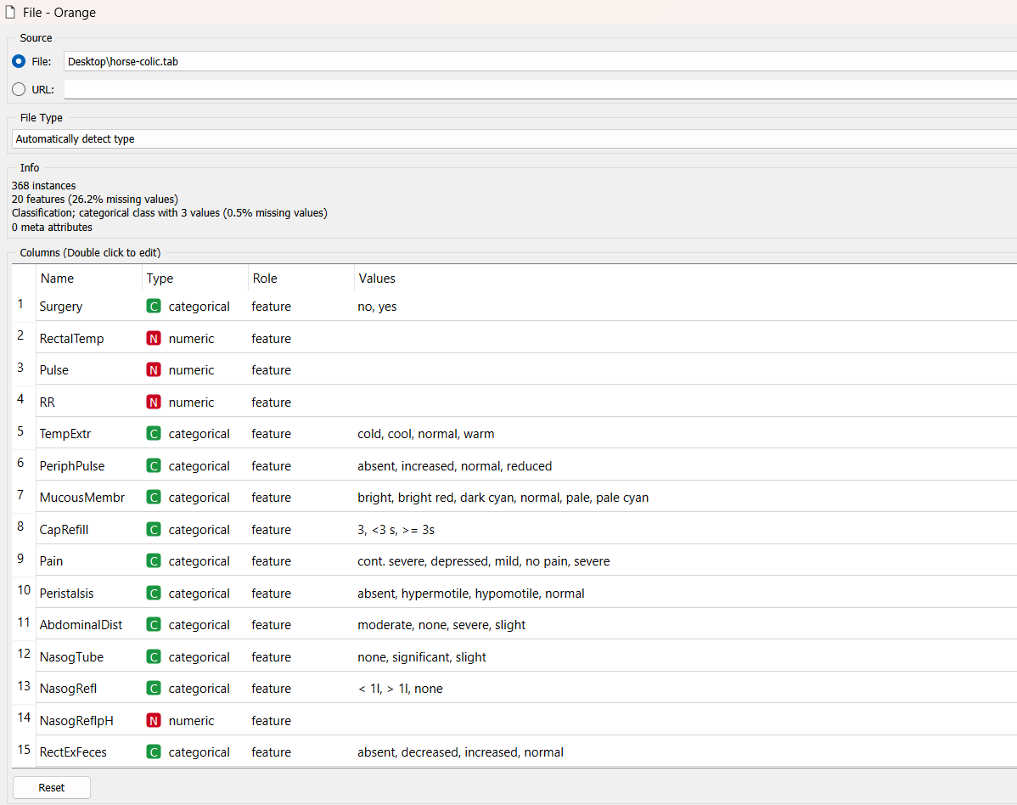

Step1 :Preprocessing

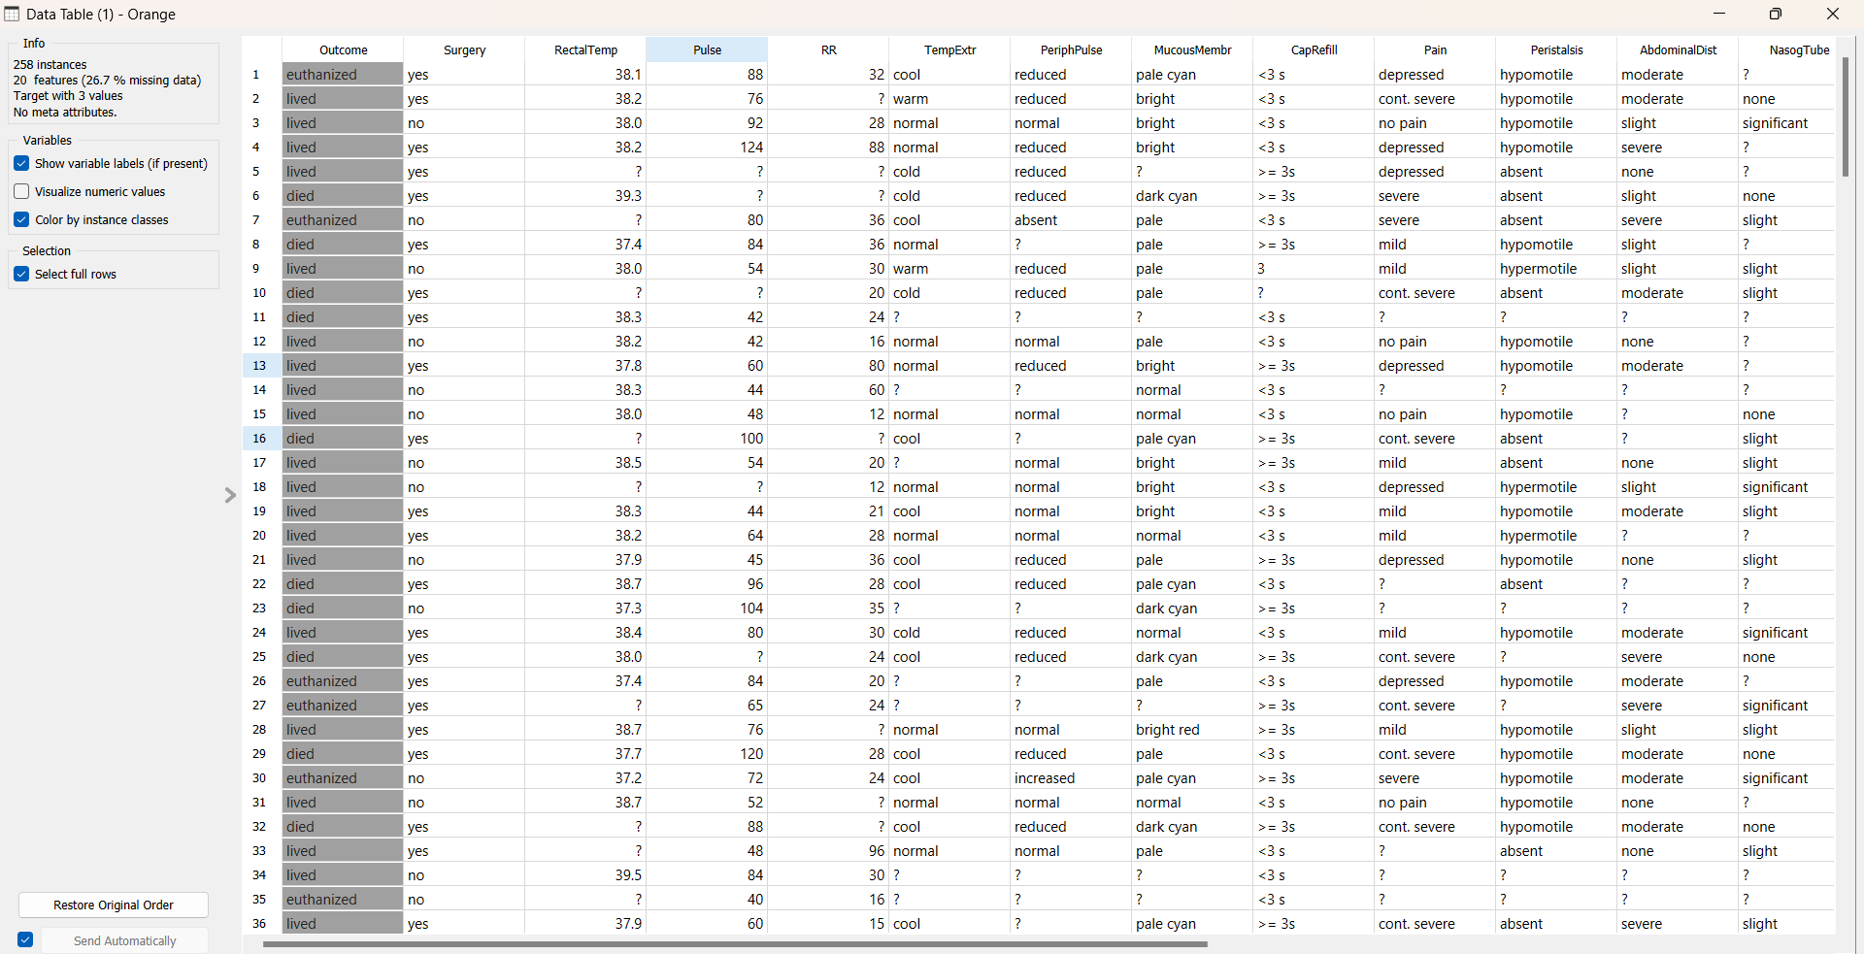

Impute missing values : Replace with random value

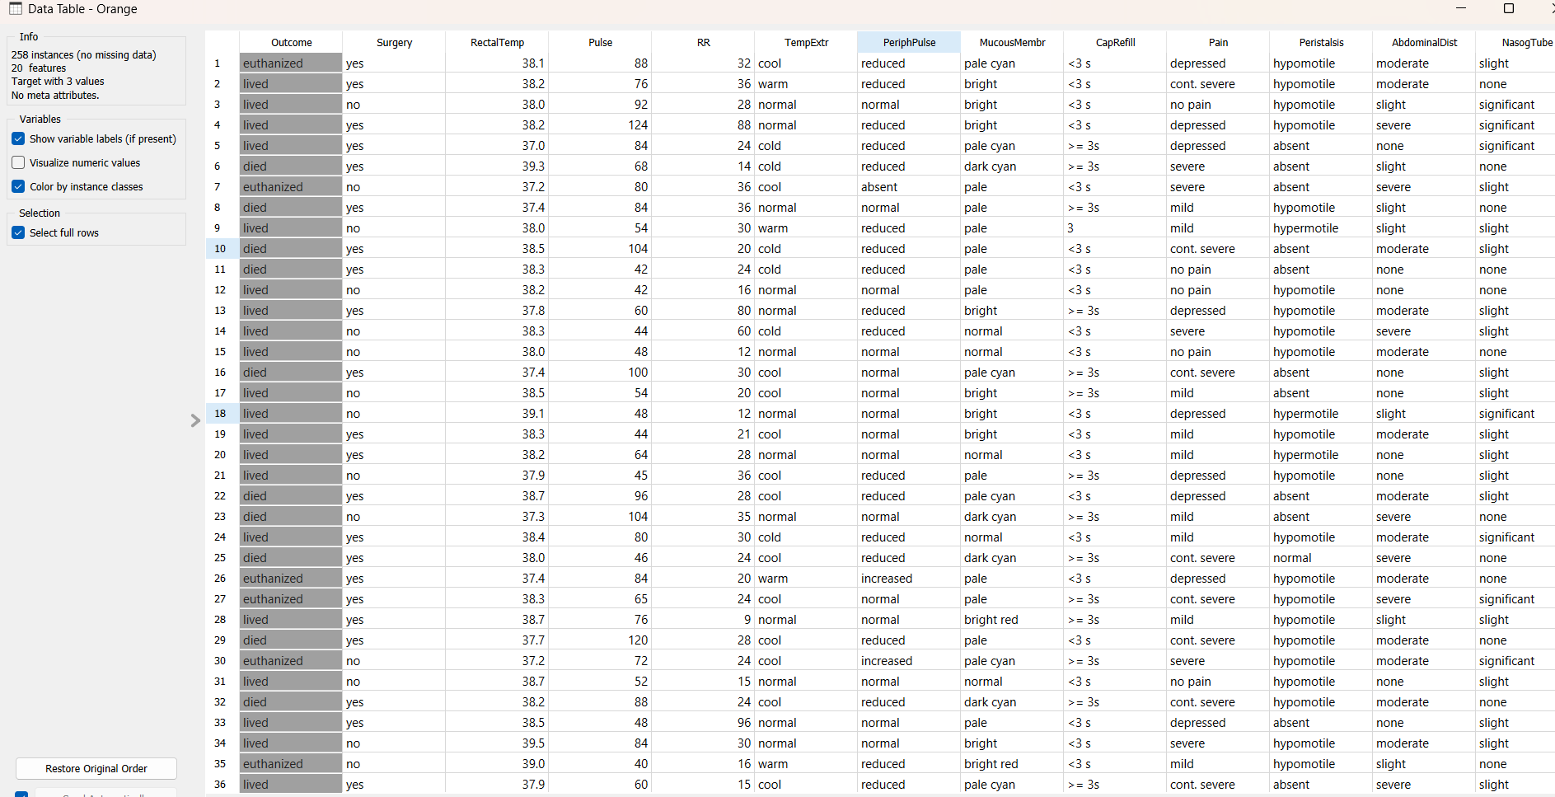

Continuous discrete variables : One feature per value

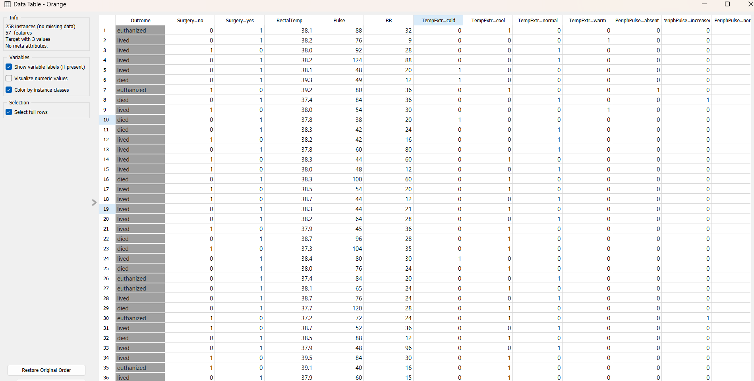

Discrete Continuous Variables: Equal frequency discretization

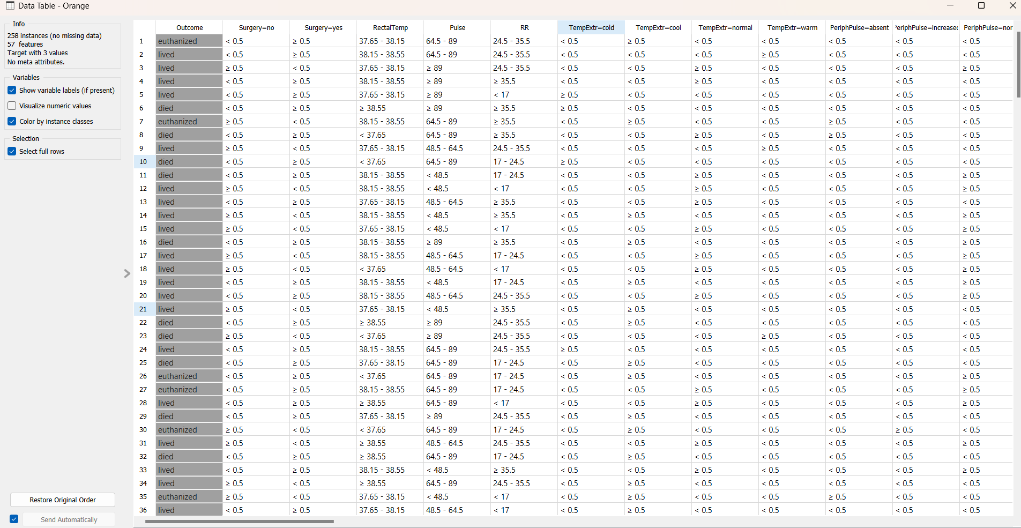

Step2 : We opted classification technique

1.KNN

2.Neural Network

3.SVM

4.Navie Bayes

5.Tree

TEST AND SCORE:

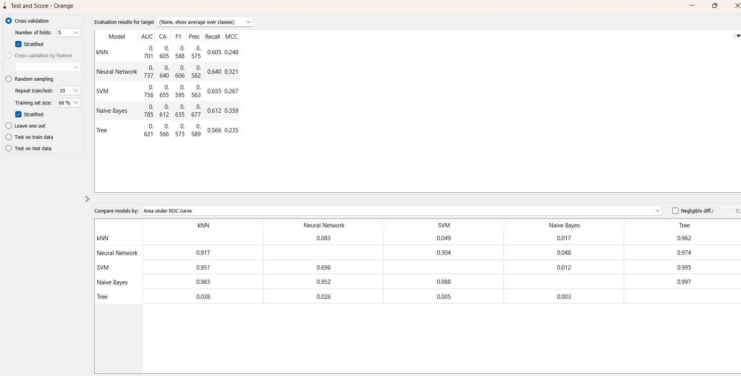

TREE:

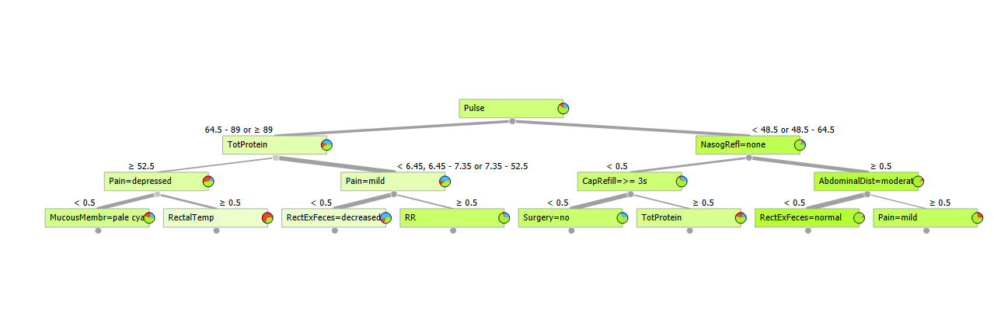Pulse is declared as root because the information gain of pulse is highest of all.

RANK :



DISTRIBUTIONS:

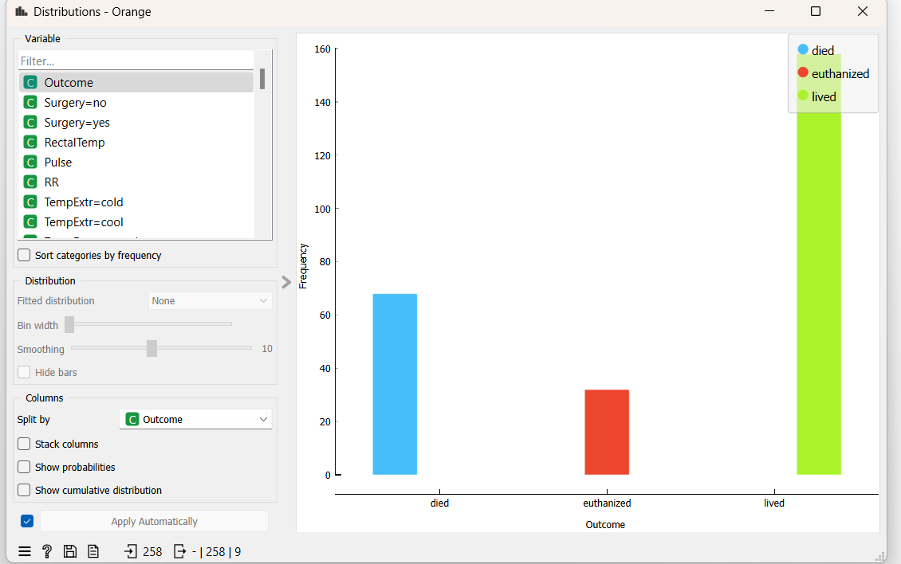

CONFUSION MATRIX:

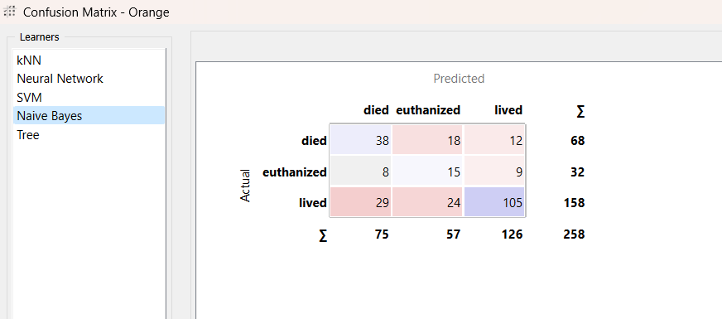

OBSERVATIONS:

1.Total 21 attributes(input:20,output:1)

2.Preprocessing: Impute missing values

Continuous discrete variables

3.Classification techniques used: KNN ,Neural Network ,SVM ,Navie Bayes ,Tree

4.In tree we find “pulse” as root

5.The values of Accuracy ,Precision ,F1_score are nearer to each other in confusion matrix

OUTPUT:

ROC Analysis

For target : died

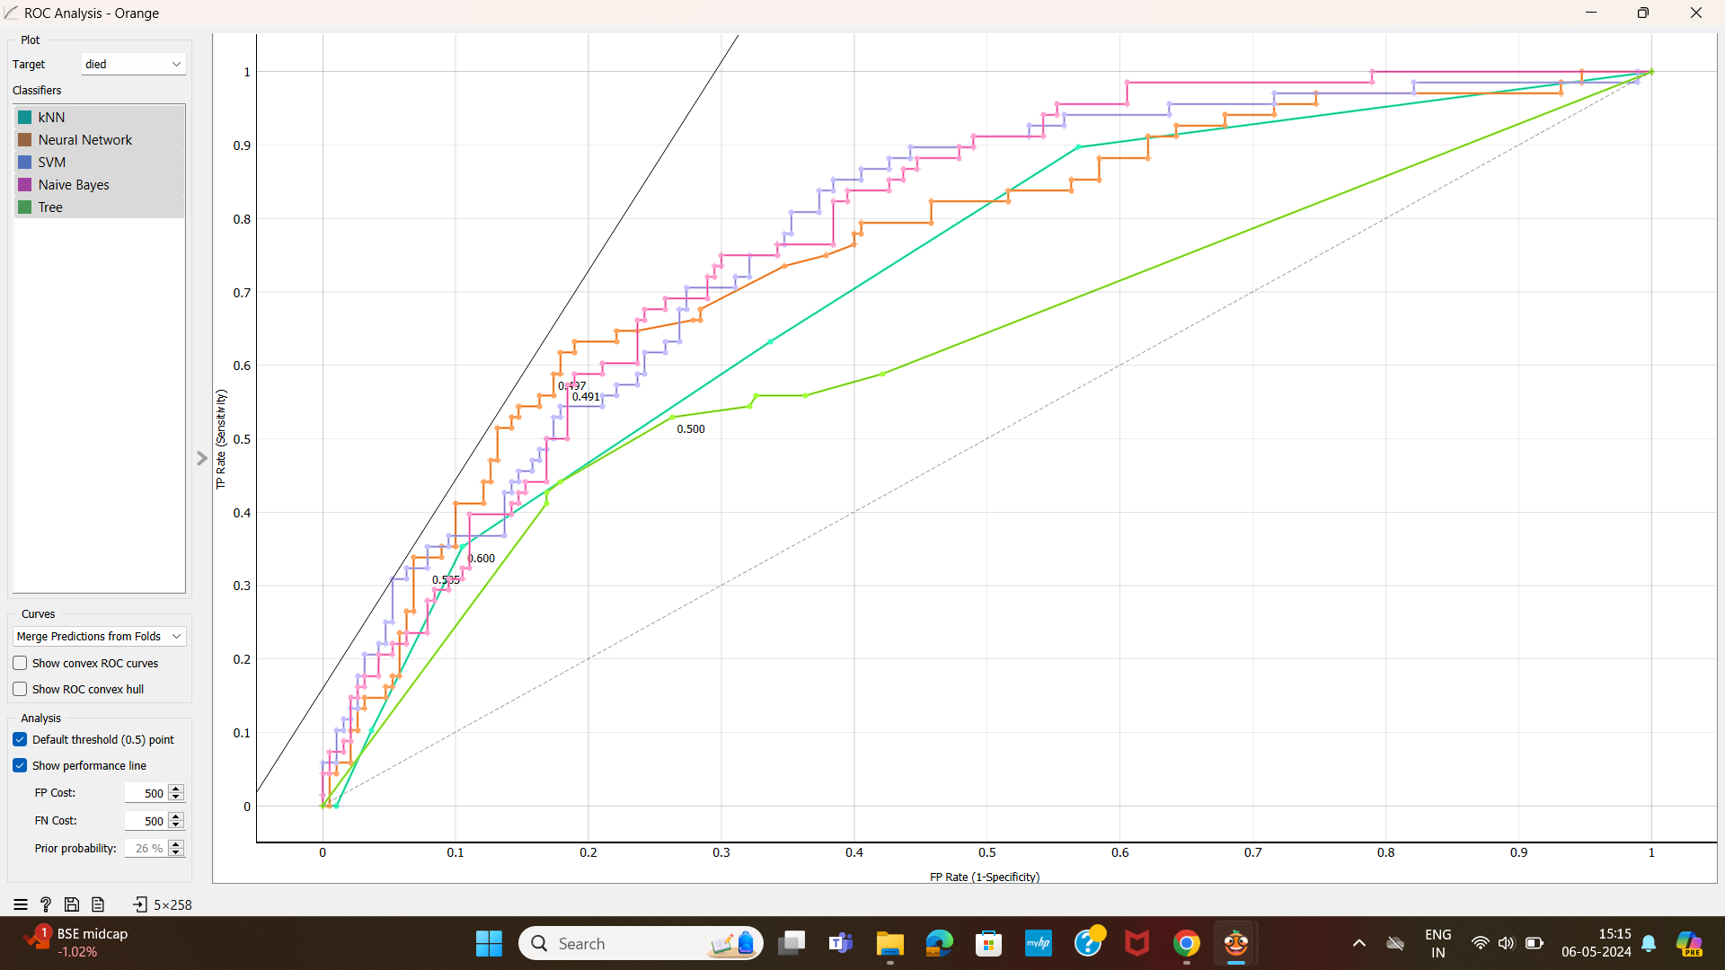

For target:enthanized

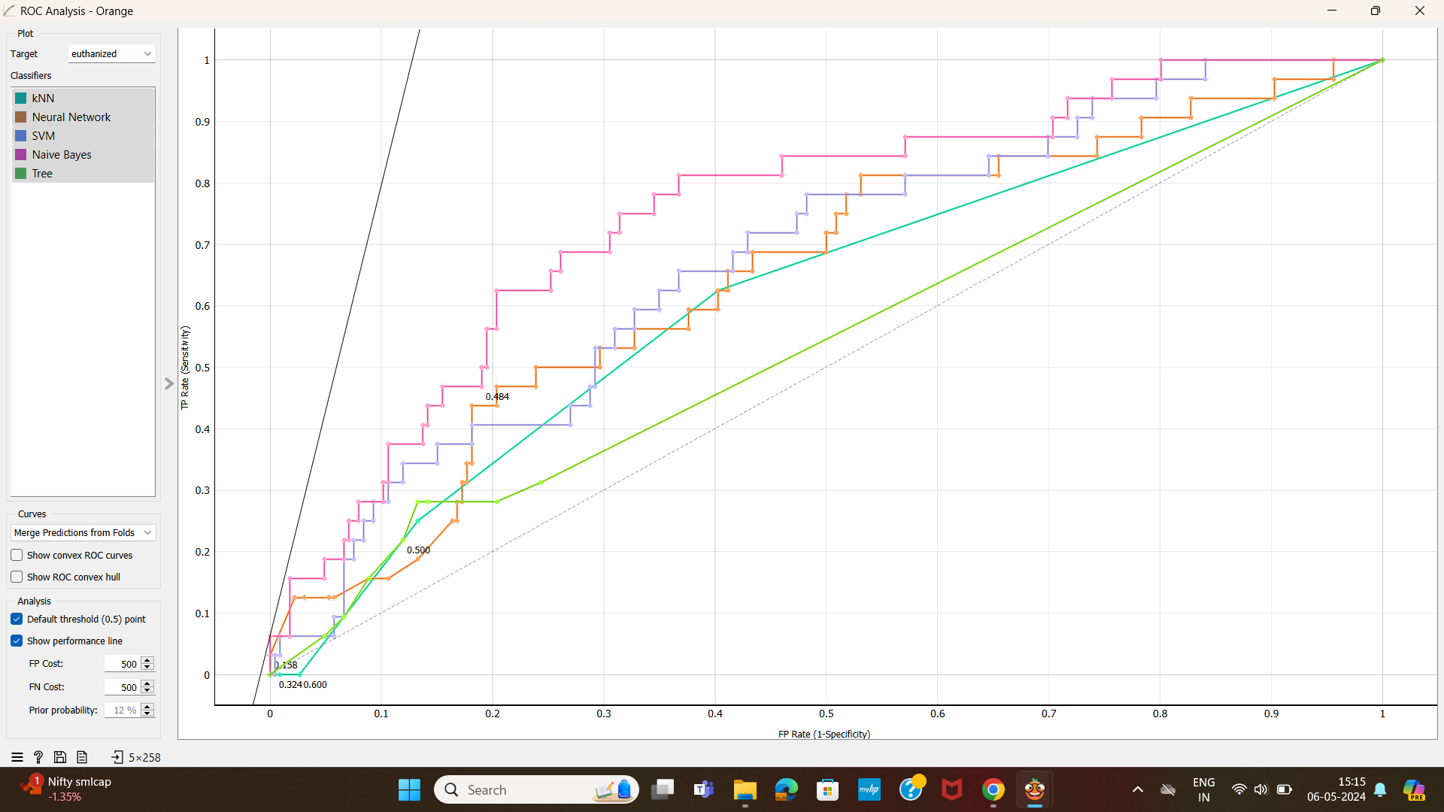

For target : lived

